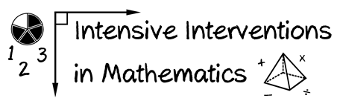
- Module 8
- Part 1
- Discussion

Share your fidelity checklist from Activity #3 and describe how well the tutor adhered to your checklist.

(This space is for organizing your ideas.)

