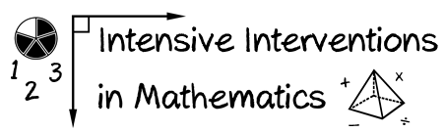
- Module 7
- Part 2
- Activity #5

- Solve the multiplication problem using two different fraction models.
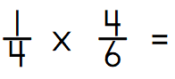

- Solve the division problem using two different fraction models.
