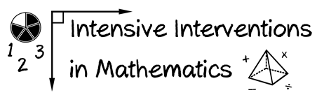
- Module 4
- Part 2
- Activity #6

Identify 10 virtual representations that you might want to use within intensive intervention.
You might want to check out the National Library for Virtual Manipulatives!
http://nlvm.usu.edu/en/nav/vlibrary.html
Virtual Representations for Intensive Intervention
1
2
3
4
5
6
7
8
9
10

