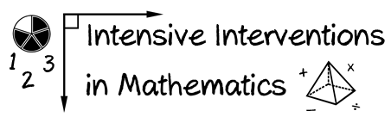
- Module 4
- Part 1
- Activity #3
Continue watching this video of intensive intervention. Fill in the table with the different components of modeling.
Practice
We Do:
Guided Practice
- Teacher and Student Practice Together
You Do: Independent Practice

- Student practices with Teacher Support

