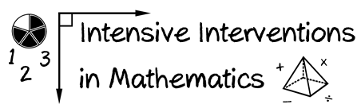
- Module 4
- Part 1
- Activity #2
Look at each of the intensive intervention topics. What would be four examples and two non-examples to use in modeling or practice?

- Add and subtract within 20.

Examples | 1.
 | 2.
 | 3.
 | 4.
Non-Examples | 1.
 | 2.
- Classify two-dimensional figures based on the presence or absence of parallel or perpendicular lines, or the presence or absence of angles of a specified size. Recognize right triangles as a category, and identify right triangles.

Examples | 1.
 | 2.
 | 3.
 | 4.
Non-Examples | 1.
 | 2.
- Understand a rational number as a point on the number line. Extend number line diagrams and coordinate axes familiar from previous grades to represent points on the line and in the plane with negative number coordinates.

Examples | 1.
 | 2.
 | 3.
 | 4.
Non-Examples | 1.
 | 2.

