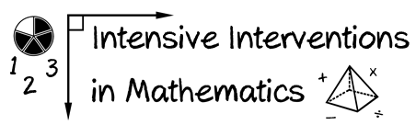
- Module 2
- Part 2
- Journal Entry
Reflect upon your current progress monitoring practices.
- What measures are available to you?
- How do you administer measures with fidelity?
- What measures would you like to use?
- How can you improve upon your progress monitoring practices?
- Why is progress monitoring an essential part of DBI?

(This space is for organizing your ideas.)

