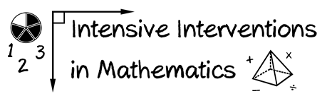
- Module 2
- Part 2
- Activity #5
Look at this Computation measure.

- Score the measure by problems correct.
- Score the measure by digits correct.
- Graph the digits correct score on the student’s graph.
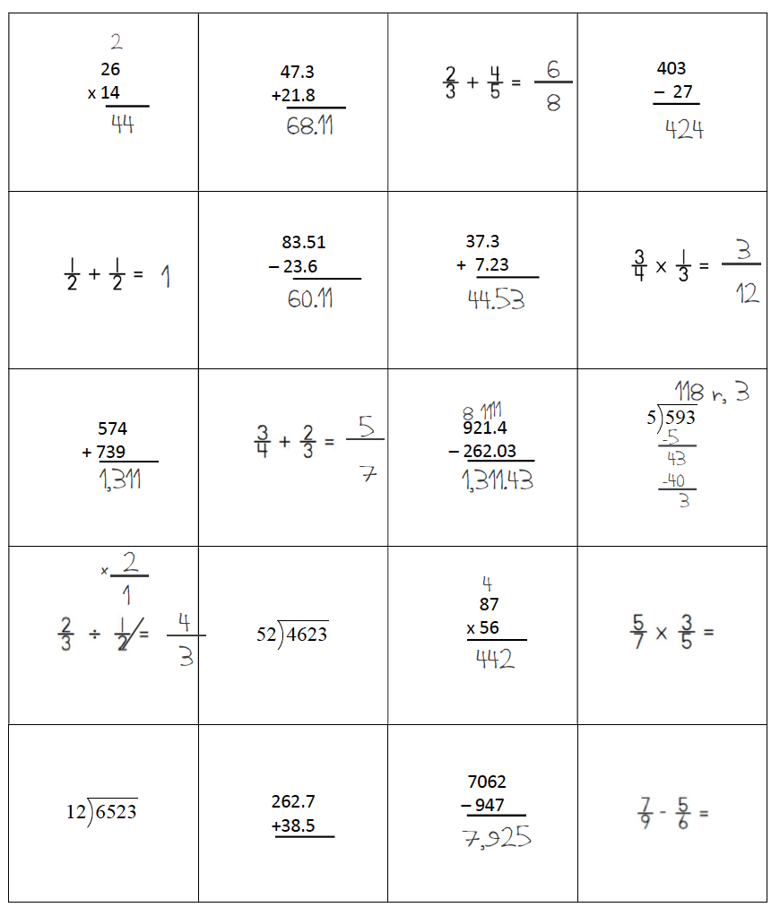
Total Number of Problems Correct:

Total Number of Digits Correct:
