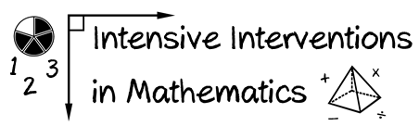
- Module 1
- Part 3
- Activity #6

Here's a list of a student's strengths and weaknesses.

Strengths:
- Addition and subtraction of whole numbers with regrouping
- Multiplication by single-digit multiplier/ division by a single-digit divisor
- Comparing whole numbers
- Interpreting graphs, tables, and charts
- Addition and subtraction of fractions with like denominators
- Multiplication of fractions
- Problem solving – single-step problems using whole number operations
Weaknesses:
- Adding and subtracting fractions with unlike denominators
- Dividing, simplifying, and comparing fractions
- Multiplication by double-digit multiplier/ division by a double-digit divisor
- Addition, subtraction, multiplication, and division of decimals
- Comparing decimals
- Problem-solving – multi-step word problems, and problems using rational numbers

- What mathematical content is important for this student in terms of intensive intervention?

- What foundational skills might be a part of intensive intervention?

- How might some of those things need to be retaught?

