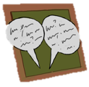
Activity 3.2 – Discussion Board
Develop Routines
Online

Before you complete this module, please complete a discussion board post that addresses the following prompts. Once you've posted, please respond to at least two of your classmates' posts.

1. Review the following linked examples.
  - Example 1
  - Example 2

2. Review and share your classroom routines.
- What routines do you currently have established in your own classroom?
- What routines would you like to establish in your own classroom?

You may use the space below to draft a copy of your response before posting a copy online.

________________________________________________________________________________________________________________________________________________________________________________________________________________________________________________________________________

