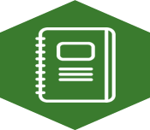
Activity 5.7 – Journal Entry for Classroom Application

Think about what Mastery Assessments you could utilize in your own classroom or field experience.
In a journal entry, answer the following questions:
- How would you decide what content to focus on?
- First steps in creating materials?
- When and to whom will you administer these measures?

Use the space below to jot down your thoughts. Then, post your response online.
_________________________________________________________________________
_________________________________________________________________________
_________________________________________________________________________
_________________________________________________________________________
_________________________________________________________________________
_________________________________________________________________________
_________________________________________________________________________
_________________________________________________________________________
_________________________________________________________________________
_________________________________________________________________________
_________________________________________________________________________
_________________________________________________________________________
_________________________________________________________________________
_________________________________________________________________________
_________________________________________________________________________
_________________________________________________________________________
_________________________________________________________________________

