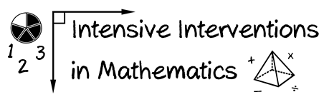
- Module 2
- Part 3
- Activity #9
Look at the graphs for these students. What decisions would you make about the progress of each student?

Decision:

Decision:

Decision:

