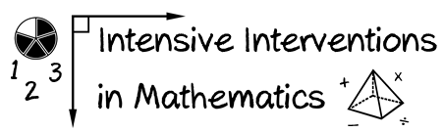

Module 8

Use the activities in this workbook as a platform to demonstrate what you’ve learned about DBI and how you are implementing the DBI process in your classroom!