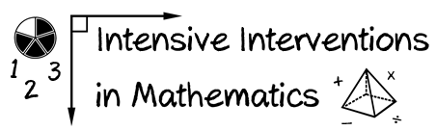
- Module 8
- Part 1
- Activity #3

First, look at the materials for a lesson on counting up.

What quantitative and/or qualitative components would you include on a fidelity checklist?

Hi, ________________________________,

Today we are going to practice counting up to help us with adding. This is important, because you don’t always know the answer for an addition problem right away in your head, but you can still answer problems you don’t know, really quickly!

First, I want you to look at this problem. (Point to A.) It says 6 plus 8 is the same as blank. Show me how you would answer this problem.

Student responds.

Awesome work! Sometimes when you add two numbers together, you know the answer right away in your brain, and that’s great! But sometimes, we don’t know the answer right away. Counting up is a neat trick to help you figure out the answer quickly.
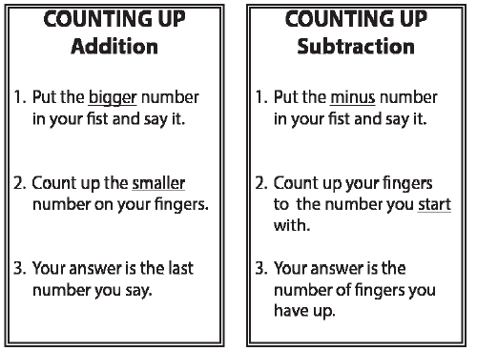

Display Counting Up Addition poster.

This poster shows the three steps to counting up for adding. Let’s use these steps to solve 4 plus 2 is the same as blank. (Point to B.)

The first step says, “Put the greater number in your fist and say it.” (Point to Step 1.) Greater means bigger, larger, or more. Which number is more?

4.

That’s right! Start with the greater number, 4. Put that number in your fist and say, “4.”

Tap closed fist on leg and say, “4.”

Look at Step 2. (Point to Step 2.) Step 2 says, “Count up the lesser number on your fingers.” Now, count up 2 more, and use your fingers to keep track of how many you’re adding. Watch me.

I put the greater number in my fist, 4 (tap closed fist on leg), 5 (hold up 1 finger), 6 (hold up 2 fingers). I knew I had to add 2 more to 4 (point to“+ 2”). I used my fingers to make sure I counted up exactly 2 more (show students the 2 fingers still held up).

Now look at Step 3. (Point to Step 3.) Step 3 says, “Your answer is the last number you say.” Watch: I put the greater number in my fist, 4 (tap closed fist on leg), 5 (hold up 1 finger), 6 (hold up 2 fingers). What was the last number I said out loud?

6.

So, what’s the answer to 4 plus 2?

6.

That’s right! 4 plus 2 is the same as 6. Write 6 in the blank.

(Student writes 6.)

Just like the number line, be careful! When you count up with your fingers, don’t put a finger up for the number you start with. That number goes in your fist. You have to add more fingers!

Watch me. I’ll practice this problem. (Point to C.) 7 plus 3 is the same as blank. I put the greater number, 7, in my fist. (Tap closed fist on leg and say, “7.”) Then I count up 3 more. Watch: 8 (hold up 1 finger), 9 (hold up 2 fingers), 10 (hold up 3 fingers). 10 is the last number I say. That’s the answer. Write 10 in the blank.

(Student writes 10.)
I use my fingers to keep track of how many I add. So, 7 plus 3 is the same as 10. 10 is more than 7 and more than 3. Your answer is always more than each of the numbers you add together.

Before we solve the next problem, I’ll tell you something cool about addition problems. In addition problems, you always start with the greater number. It doesn’t matter

whether the greater number is here (point to 7 of 7 + 3) or here (point to 3 of 7 + 3). You always start with the greater number. What number do you always start with?

The greater number.

That’s right! For addition problems, you always start with the greater number.

The greater number.

That’s right! For addition problems, you always start with the greater number.

Now, let’s practice counting up together. Look at this problem. (Point to D.) This problem says 3 plus 4 is the same as blank. In this problem, the greater number, 4, doesn’t come first. You still solve the problem the same way, though.

What number do you put in your fist?

4.

Yes, put the 4 in your fist.

(Student taps closed fist on leg and says) 4.

How many do you count up?

3.

So, count up 3 more.

- (student holds up 1 finger), 6 (student holds up 2 fingers), 7 (student holds up 3 fingers).

So, what’s 3 plus 4?

7.

Yes, 7 was the last number you said. 7 is the answer. 3 plus 4 is the same as 7. Write your answer in the blank.

(Student writes 7.)

Let’s try this problem. (Point to E.) 6 plus 4 is the same as blank. Show me how to count up 6 plus 4.

(Student counts up.)

Very good. (Count up 6 plus 4.) 6 plus 4 is the same as 10. Write your answer in the blank.

(Student writes 10.)
Let’s try another problem. (Point to F.) This problem says 5 plus 8 is the same as blank. This is an addition problem, so the answer is more than each of the numbers you add together. Try counting up 5 plus 8.

(Student counts up.)

Great. (Count up 5 plus 8.) 5 plus 8 is the same as 13. Write your answer in the blank.

(Student writes 13.)

(Point to G.) This problem says 7 plus 6 is the same as blank. Show me how to count up 7 plus 6.

(Student counts up.)

Awesome. (Count up 7 plus 6.) 7 plus 6 is the same as 13. Write 13 in the blank.

(Student writes 13.)

Let’s try one more problem. (Point to H.) Show me how to count up 8 plus 9.

(Student counts up.)

Yes! (Count up 8 plus 9.) 8 plus 9 is the same as 17. Great job! Write 17 in the blank.

(Student writes 17.)

Nice work with addition! You earn a treasure coin!
(Lesson adapted from 3rd Grade Pirate Math, Texas Edition)

Your “Counting Up” Fidelity Checklist

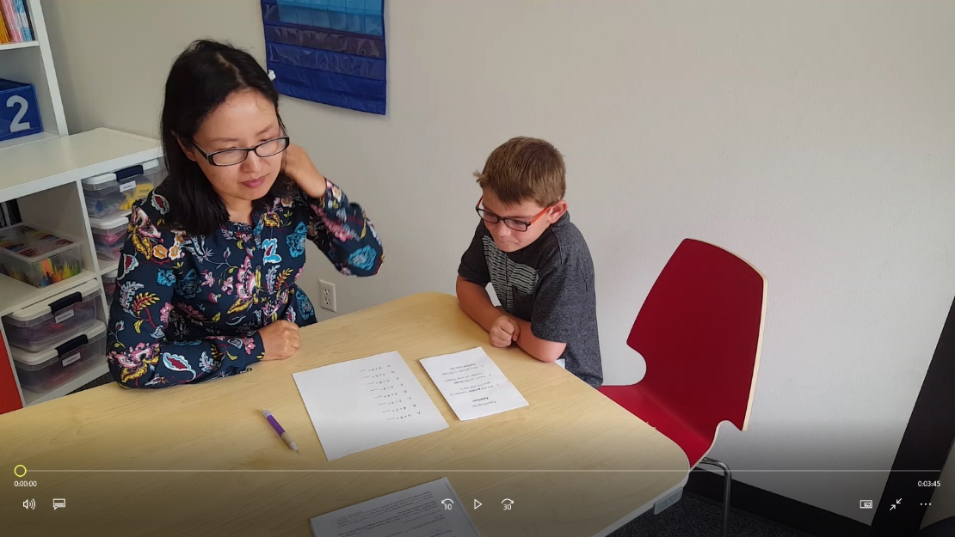
Then, watch the video.

Rate the tutor against your checklist.

