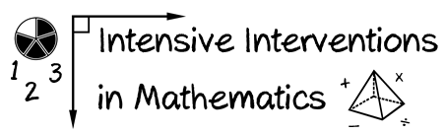

Module 7

- List two ways to increase your modeling of rational-number concepts (and do it!)
Model Concepts 1:

Evidence:

Model Concepts 2:

Evidence:

(2) List two ways to increase your modeling of rational-number procedures (and do it!)
Model Procedures 1:

Evidence:

Model Procedures 2:

Evidence:

