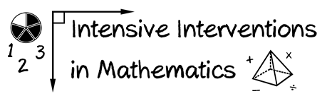
- Module 7
- Part 1
- Activity #3
Here’s Colleen’s work for showing the fraction $\frac{4}{5}.$

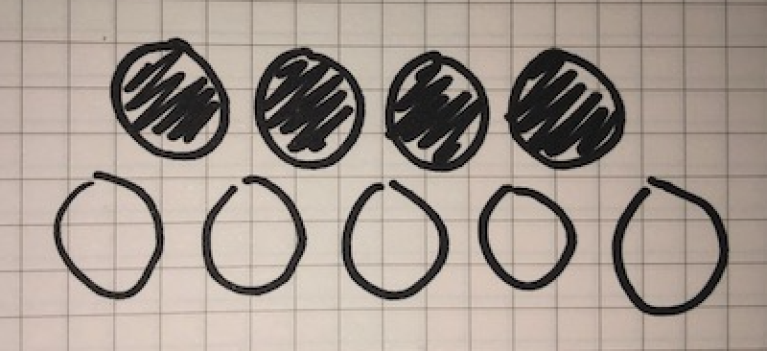

How could you use the set model to help the student understand 4/5? Draw and write your response.

