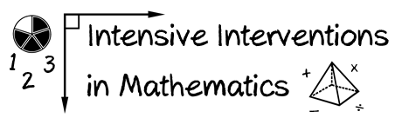
- Module 7
- Part 1
- Activity #1
Here’s Abraham’s work for showing the fraction $\frac{4}{5}.$

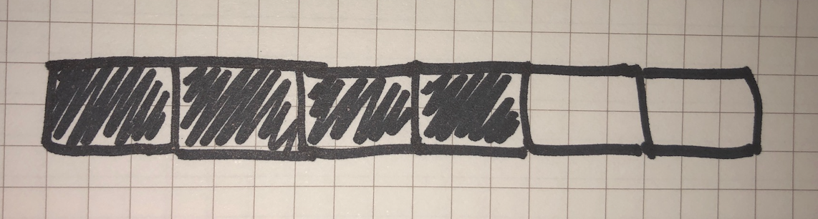

How could you use the length model to help the student understand 4/5? Draw and write your response.

