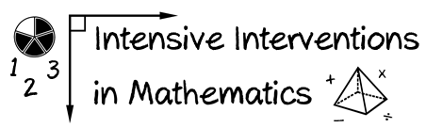

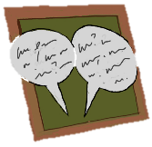
- Module 6
- Part 3
- Discussion

Make a video of yourself solving a multi-digit addition, subtraction, multiplication, or division problem using nonstandard algorithms.

Share your experience with your classmates for examples and new understanding.

Write an original post on the Discussion Board and respond to two peers.
(This space is for organizing your ideas.)

