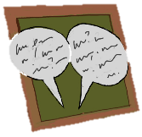
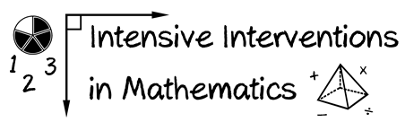
- Module 6
- Part 2
- Discussion

Suppose that you’re teaching multi-digit addition, subtraction, multiplication, or division (you choose). You want to explain to a parent or guardian how to use an alternate algorithm.

Take a picture listing the steps or make a brief video of you explaining one alternate algorithm, just as you would to the parent or guardian.

Upload the picture or video and discuss this with your colleagues.

Write an original post on the Discussion Board and respond to two peers.
(This space is for organizing your ideas.)

