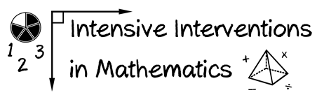
- Module 6
- Part 2
- Activity #5

- Solve the addition problem using two different algorithms.

2 5 6
+ 4 9 9
2 5 6
+ 4 9 9

- Solve the subtraction problem using two different algorithms.

8 2 3
– 4 7 8
8 2 3
– 4 7 8

