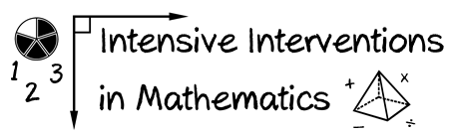
- Module 6
- Part 1
- Activity #3

Look at problem A. Describe and draw two conceptual understandings of multiplication.
- 2 × 4 = ____

Look at problem B. Describe and draw two conceptual understandings of division.
- 10 ÷ 5 = ____

