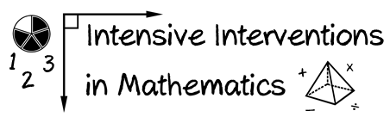
- Module 6
- Part 1
- Activity #2

Read about how each student interprets addition and subtraction.
- How does Martin interpret addition?
Martin: I have 1, 2, 3, 4, 5 blue candies. I also have 1, 2, 3 green candies. If I put all the candies together, I have: 1, 2, 3, 4, 5, 6, 7, 8. I have 8 candies!

- What would be another way to explain addition to Martin?

- How does Lola interpret subtraction?
Lola: I have 1, 2, 3, 4, 5, 6, 7, 8, 9 stickers. If I put 3 stickers on my folder, I have 1, 2, 3, 4, 5, 6 stickers left.

- What would be another way to explain subtraction to Lola?

