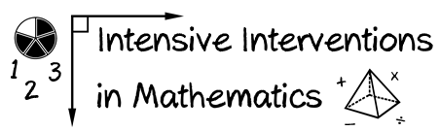
- Module 5
- Part 3
- Discussion
Share a motivational strategy that you find helpful to use with a student. Share a video of the strategy in use or share the materials you use with the student.
(This space is for organizing your ideas.)

