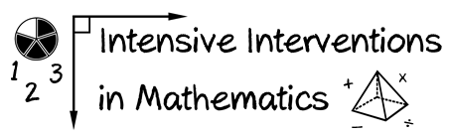
- Module 5
- Part 2
- Activity #6
Video Debrief
In this activity, you’ll identify the schema of several multiplicative word problems.
- Read the word problem.
- Identify the schema.
- Solve the problem using the schema.

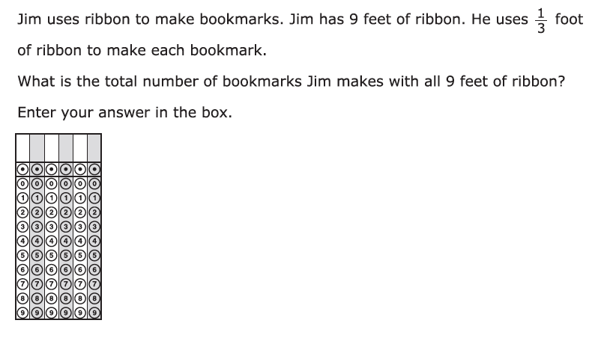

A

PARCC fifth-grade release item (2014)
- Read the word problem.

- What’s the schema? _________________________________

- Solve the problem using the schema.

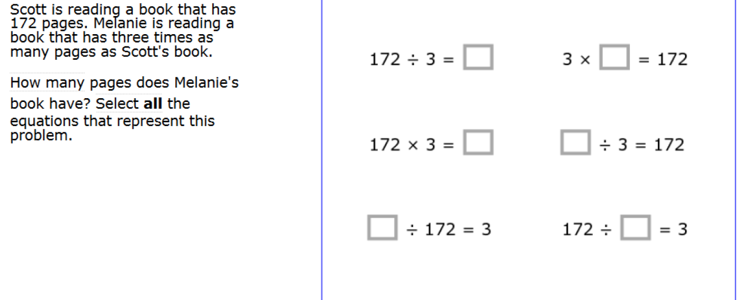

B

SmarterBalanced fourth-grade release item (2014)
- Read the word problem.

- What’s the schema? _________________________________

- Solve the problem using the schema.

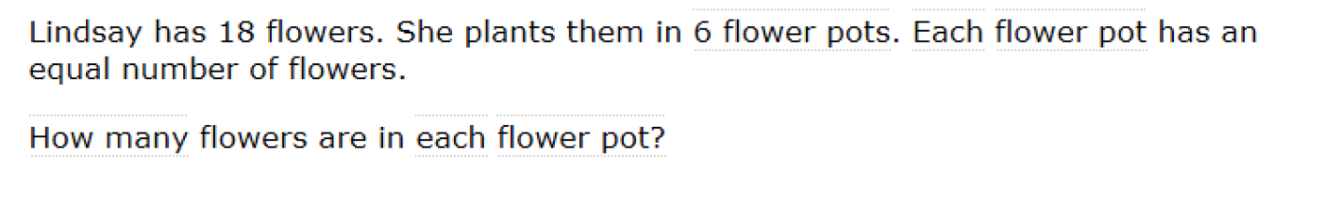
C

SmarterBalanced third-grade release item (2014)
- Read the word problem.

- What’s the schema? _________________________________

- Solve the problem using the schema.

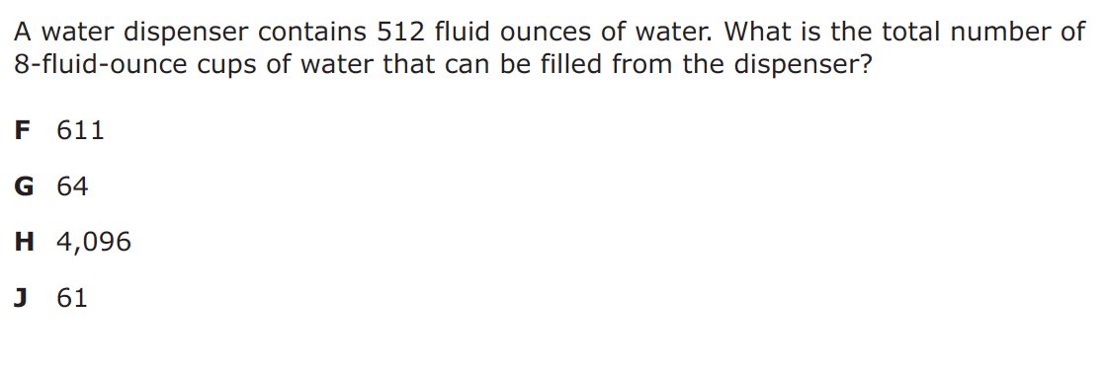

D

STAAR fifth-grade release item (2014)
- Read the word problem.

- What’s the schema? _________________________________

- Solve the problem using the schema.

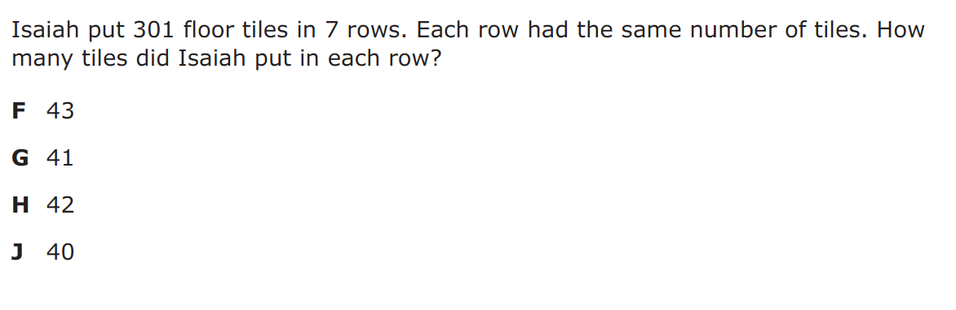

E

STAAR fourth-grade release item (2014)
- Read the word problem.

- What’s the schema? _________________________________

- Solve the problem using the schema.

Don’t Forget: Video Debrief!

