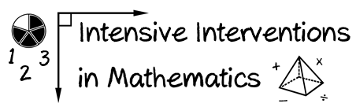
- Module 5
- Part 2
- Activity #5
Video Debrief
In this activity, you’ll identify the schema of several additive word problems.
- Read the word problem.
- Identify the schema.
- Solve the problem using the schema.
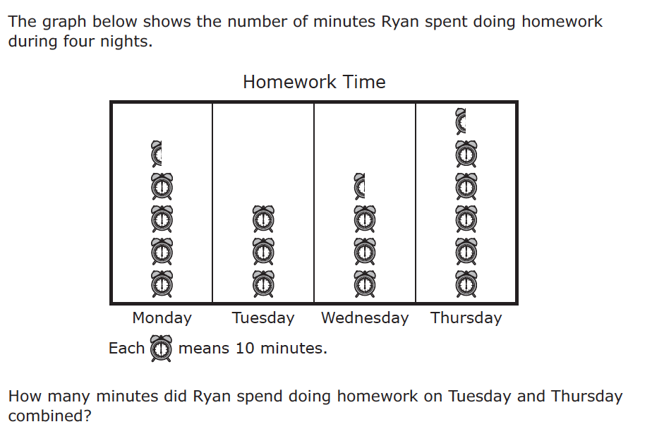

A

STAAR third-grade release item (2014)
- Read the word problem.

- What’s the schema? _________________________________

- Solve the problem using the schema.

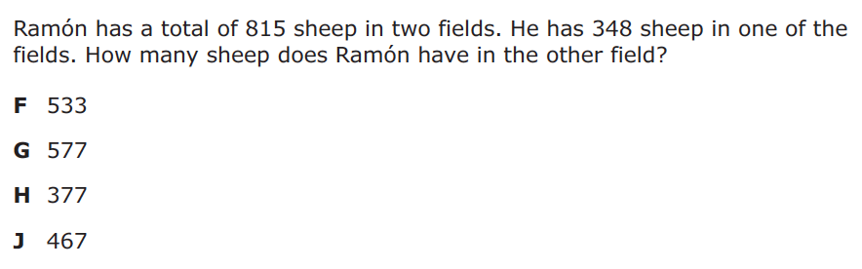

B

STAAR third-grade release item (2014)
- Read the word problem.

- What’s the schema? _________________________________

- Solve the problem using the schema.

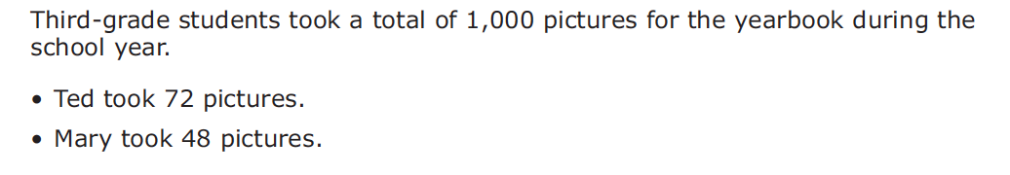
C

PARCC third-grade release item (2015)
- Read the word problem.

- What’s the schema? _________________________________

- Solve the problem using the schema.

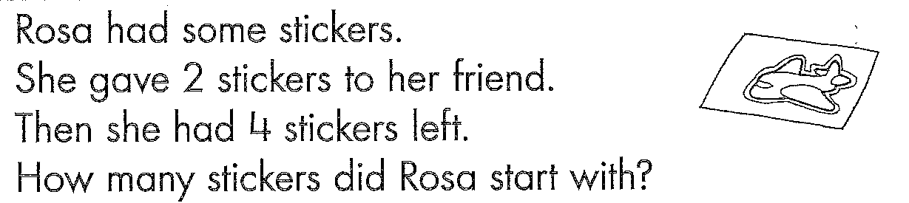
D

- Read the word problem.

- What’s the schema? _________________________________

- Solve the problem using the schema.

E

SmarterBalanced third-grade release item (2014)
- Read the word problem.

- What’s the schema? _________________________________

- Solve the problem using the schema.

Don’t Forget: Video Debrief!

