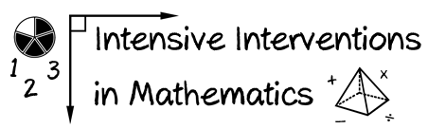

- Module 4
- Part 3
- Discussion

Share three examples of "instead of…, say…!" with your classmates.
Write an original post on the Discussion Board and respond to two peers.
(This space is for organizing your ideas.)

