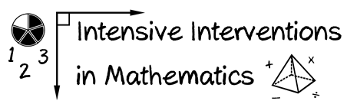
- Module 4
- Part 1
- Activity #1
Watch this video of intensive intervention. Fill in the table with the different components of modeling.
I Do: Modeling
Clear Explanations

- Goal and Importance
- Model Steps
- Concise Language
Planned Examples

- Examples
- Non-Examples

