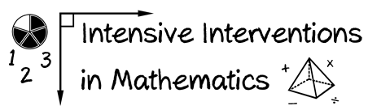
- Module 3
- Part 3
- Activity #6
Using the resources we’ve discussed (and additional resources), what evidence-based interventions and evidence-based strategies are available at the grade(s) you teach?
What’s the quality of the evidence?
Evidence-based Interventions | Location of Evidence | Quality of Evidence
Evidence-based Strategies | Location of Evidence | Quality of Evidence

