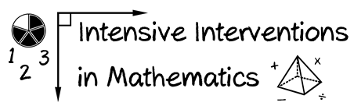

* Module 3
* Part 3
* Activity #5

**You met Emma in the module about assessment within DBI.**

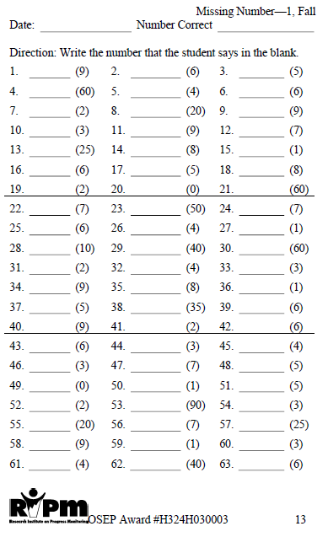

✓

--

6

**https://www.progressmonitoring.org**/

2

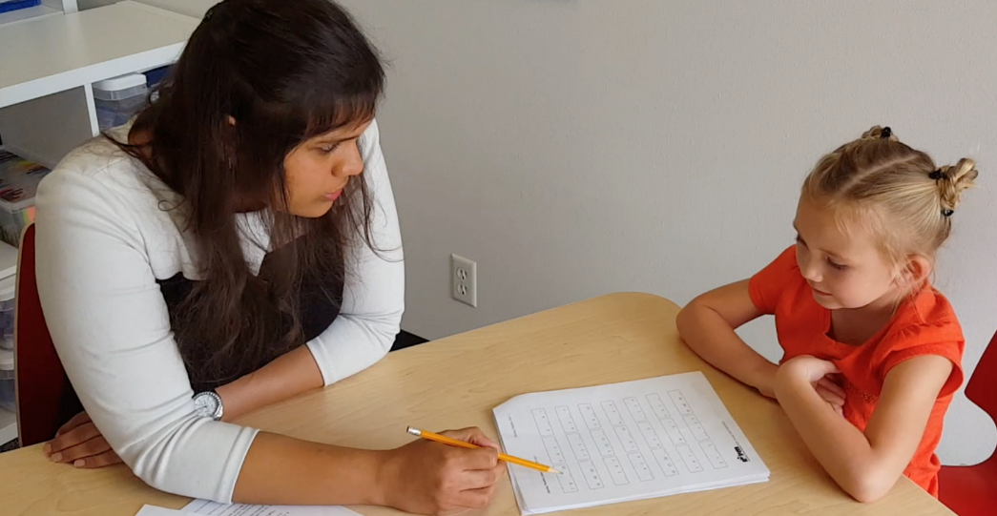

**This student had 1 correct response out of 4 attempts.**

missing number worksheet

9C

--C

6C

2C



* Module 3
* Part 3
* Activity #5 (cont.)

***Emma’s ENI Results***

|  |  |  |  |
| --- | --- | --- | --- |
| **Subtest** | **Emma’s Scores** | **Strengths** | **Weakness** |
| **Number Identification** | **12/22** | Fluent on numbers less than 20 | Did not correctly identify any numbers greater than 20 |
| **Quantity Discrimination** | **16/16** | Accurate with numbers less than 20 | (All numbers were less than 20) |
| **Missing Number** | **1/4** | None identified. | Supplying a missing number in sequence, even when counting by ones |

**Considering the mathematical strengths and weaknesses of Emma:**

1. **What would be a scope and sequence for Emma?**
2. **What evidence-based interventions or evidence-based strategies are available?**