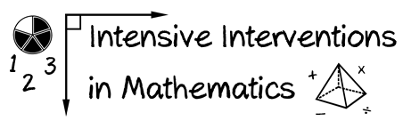
- Module 3
- Part 1
- Activity #2
Look at the same examples of different evidence-based practices. How would YOU rate the evidence?
Name of Practice | Improvement from Before Intervention | Improvement Compared to No Treatment Students | Multiple Researchers | Multiple Students | Multiple Times | Setting and Students Similar to Your Own? | Your Overall Rating
Number Rockets
Explicit Instruction
Taped Problems
Roots
Word Problem Mnemonics
Incremental Rehearsal
Schema-based Instruction
Concrete-Representational-Abstract (CRA)
Pirate Math

