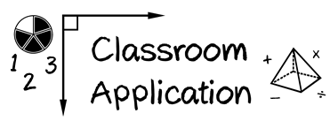

Module 2

- Start (or continue) implementing progress monitoring measures on a weekly basis.
Goals:

Evidence of progress:

(2) Start (or continue) graphing data.

Goals:

Evidence of progress:

(3) Start (or continue) making decisions about progress.

Goals:

Evidence of progress:

