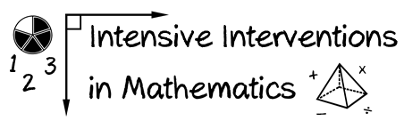
- Module 2
- Part 2
- Activity #4
Watch the videos and score each early numeracy measure.
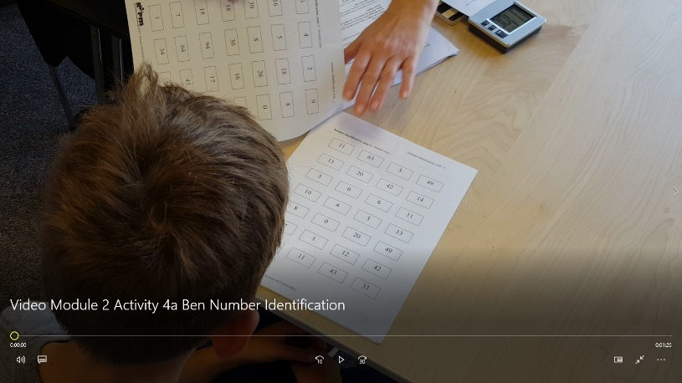
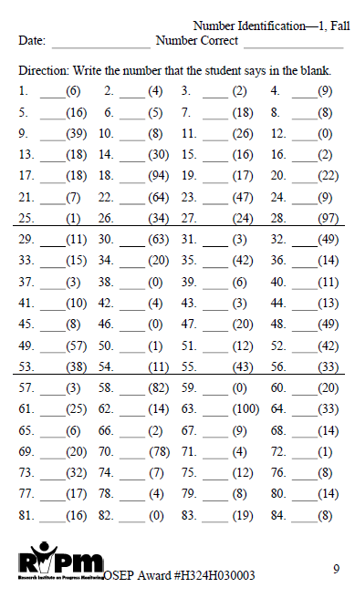
Early Numeracy Indicators: Number Identification
Use this video and score along with the teacher.
https://youtu.be/2YidrJ3zabQ

https://www.progressmonitoring.org/

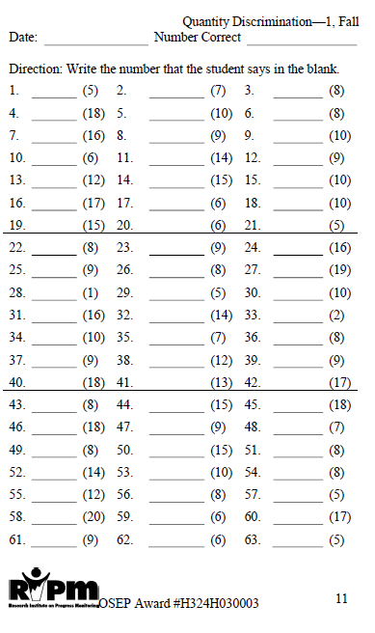
Early Numeracy Indicators: Quantity Discrimination
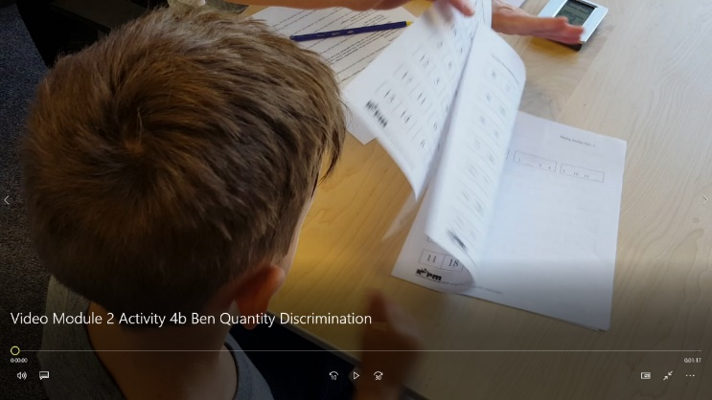
Use this video and score along with the teacher.
https://youtu.be/tof8mNnzvZw

https://www.progressmonitoring.org/

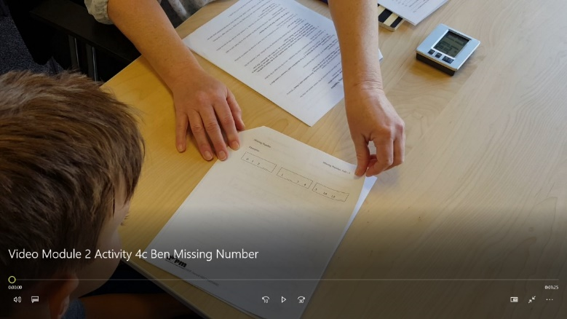
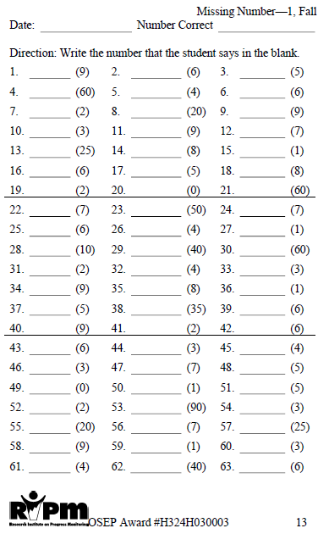
Early Numeracy Indicators: Missing Number
Use this video and score along with the teacher.
https://youtu.be/CxeZ35d6h18

https://www.progressmonitoring.org/

