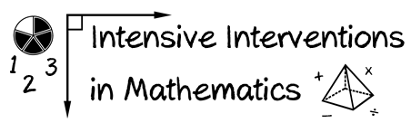

* Module 2
* Part 1
* Activity #1

**Look at the examples of formative assessments.**

**Is each an example of a general outcome measure or single-skill measure?**

1. **­­­­­­­­­­­­­­­­­­­­­­­­­­­­_________________________________**

|  |  |  |  |
| --- | --- | --- | --- |
| 5 + 6 = | 7 + 8 = | 2 + 4 = | 3 + 6 = |
| 9 + 5 = | 4 + 7 = | 1 + 8 = | 9 + 3 = |

1. **_________________________________**

|  |  |  |  |
| --- | --- | --- | --- |
| 26  × 14 | 47.3  + 21.8 | 2/3 plus 4/5 | 403  – 27 |
| 1/2 plus 1/2 | 83.5  – 23.6 | + 7.23  37.3 | 3/4 times 1/3 |

1. **_________________________________**

|  |  |  |  |
| --- | --- | --- | --- |
| 2  + 5 | 12  – 3 | 83  + 12 | 62  – 21 |
| 9 + 5 = ___ | 14  + 28 | 37  – 15 | 11 – 3 = ___ |

1. **_________________________________**

|  |  |  |  |
| --- | --- | --- | --- |
|  |  |  |  |
|  |  |  |  |