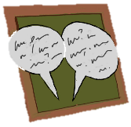
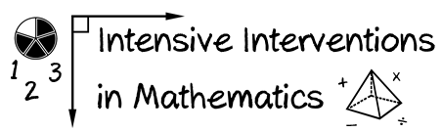
- Module 1
- Part 2
- Discussion

Reflect upon something that you're teaching soon.
- What's the content that the student knows?
- What comes before? What comes after?
- How does this knowledge change your instruction?
- What questions might you have for other teachers?

Write an original post on the Discussion Board and respond to two peers.
(This space is for organizing your ideas)
___________________________________________________________________
___________________________________________________________________
___________________________________________________________________
___________________________________________________________________
___________________________________________________________________
___________________________________________________________________
___________________________________________________________________
___________________________________________________________________
___________________________________________________________________
___________________________________________________________________

