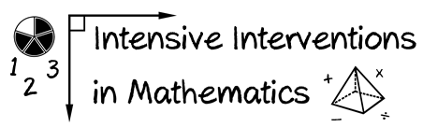
- Module 1
- Part 2
- Activity #3

Place the problem-solving content in order from easier skills to more difficult skills. (Number from 1-9.)
Solve multi-step word problems posed with whole numbers and having whole-number answers using the four operations.
______
Solve word problems involving addition and subtraction of fractions referring to the same whole, including cases of unlike denominators.
______
Solve word problems that call for addition of three whole numbers whose sum is less than or equal to 20.
______
Solve real-world and mathematical problems involving the four operations with rational numbers.
______
Solve real-world and mathematical problems leading to two linear equations in two variables.
______
Solve addition and subtraction word problems, and add and subtract within 10.
______
Use addition and subtraction within 100 to solve one- and two-step word problem.
______
Interpret and compute quotients of fractions, and solve word problems involving division of fractions by fractions.
______
Use multiplication and division within 100 to solve word problems.
______

