Activity 6.23 – Pause & Process
Solidify your Understanding
Workbook
Which methods are most efficient? Plot the remaining methods for eliciting responses on the graph below.
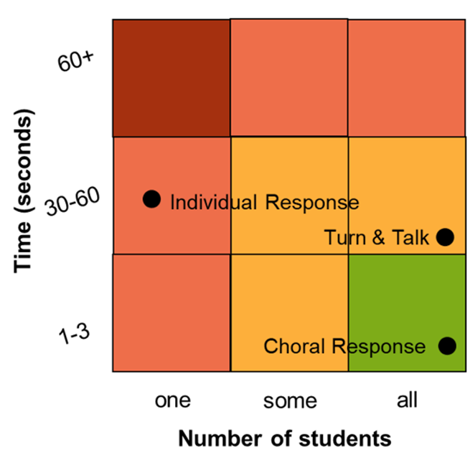
- Turn & Talk
- Choral Response
- Individual Response
- Cued Retell
- White Boards
- Response Cards
- Whip Around
- Stop & Jot
- Hand Signals

