Noah’s Goal:
- Answer who, what, where, and when questions about text
Current Skill:
- Practice retelling
- Mastery of answering who, what, where and when questions about himself
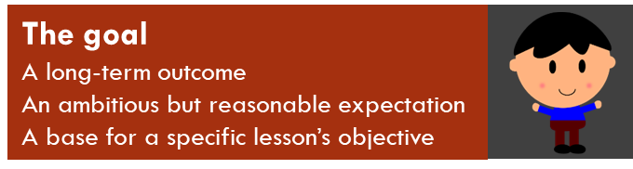
Activity 5.7 – Stop & Jot
Solidify Your Understanding
Workbook

Next Step?:
- Should he answer these four types of questions next? YES or NO

- What’s your rationale?

- What might be another next step?

