Activity 5.13 – Read & Reflect
Solidify your Understanding
Workbook
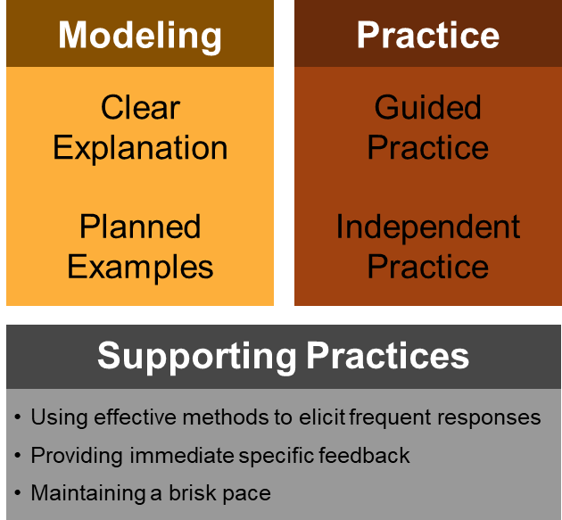
Return to the reading you completed earlier: Martin, A.J. (2016). Using Load Reduction Instruction to boost motivation and engagement. Leicester, United Kingdom: British Psychological Society.
- Read pp. 12-14
How do Martin’s instructional elements map onto the explicit instruction framework we have described? Use the notes and table below to help you answer this question.
Elements of Load Reduction Instruction
1. Reducing ________________________ of a task during ___________________________
2. Instructional ___________________ and _____________________ through the task
3. Ample ______________________________________
4. Appropriate provision of __________________________________
5. _______________________________________ and guided autonomy
Element of LRI | Key aspects of this element as described by Martin | Link to explicit instruction model
1
2
3
4
5

