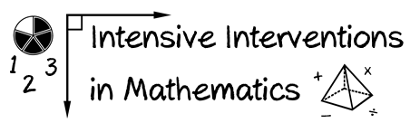
- Module 8
- Part 3
- Discussion

Share your excitement and concerns about starting (or continuing) DBI.
Write an original post on the Discussion Board and respond to two peers.
(This space is for organizing your ideas.)

