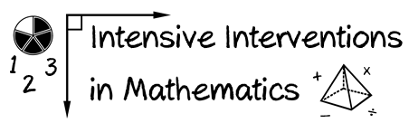
- Module 8
- Part 2
- Discussion

Describe how you will make decisions about adaptations within DBI.
Will you work on your own or with a team?
What resources will you have available?

Write an original post on the Discussion Board and respond to two peers.
(This space is for organizing your ideas.)

