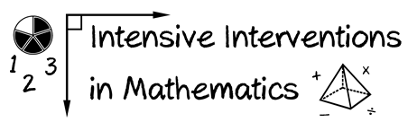
- Module 8
- Part 2
- Activity #5

Select a lesson that you taught recently. Fill in the graphic organizer about how you used explicit instruction.

Then, go back and revise your lesson by including one additional component of modeling, guided practice, independent practice, and each of the support practices. In other words, how could you have done it better?

Modeling |  | Practice
I Do |  |  | We Do
 |  |  | You Do
Supporting Practices

