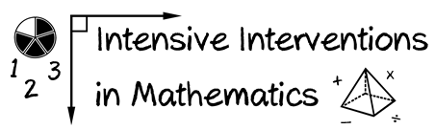
- Module 8
- Part 1
- Activity #2

Go back and look at the lesson for Activity #1.

What qualitative components would you include on a qualitative fidelity checklist?
(List at least three.)

