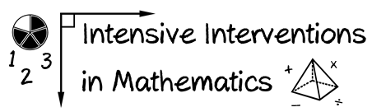

* Module 8
* Part 1
* Activity #1

**Look at the fidelity checklist and accompanying lesson.**

Pirate math fidelity of treatment (days 6 - 48) plan**Compare to understand how much detail is provided within the fidelity checklist.**

Pirate math fidelity of treatment (days 6 - 48) plan

Day 30 Activity plan

Day 30 Activity plan

Day 30 Activity plan