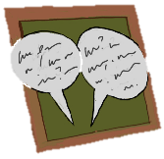
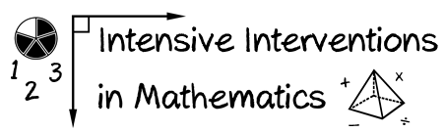
- Module 7
- Part 2
- Discussion

Reflect upon the word-problem schema of ratios and proportions.
(This was covered in the module about instructional strategies, Module 4.)

How could you use some of the information in this module to help students understand ratios, unit rate, proportions, and percentages better?

Write an original post on the Discussion Board and respond to two peers.
(This space is for organizing your ideas.)

