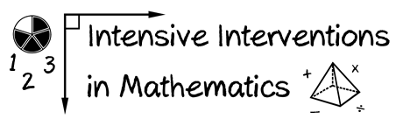

* Module 6
* Part 2
* Activity #6

1. **Solve the multiplication problem using two different algorithms.**

1 4

× 4 8

1 4

× 4 8

1. **Solve the division problem using two different algorithms.**