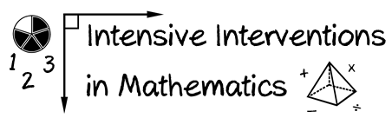
- Module 6
- Part 1
- Activity #4

Look at these word problems.
- What concepts of multiplication should be emphasized?
- What concepts of division should be emphasized?

A.
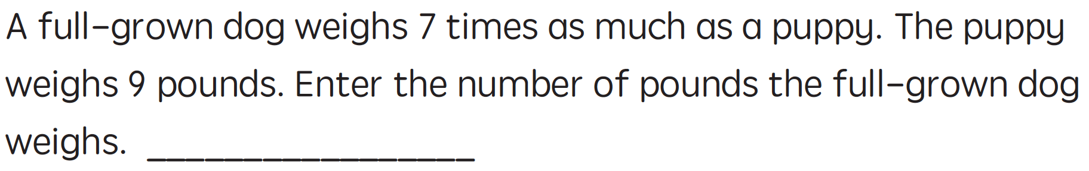

B.
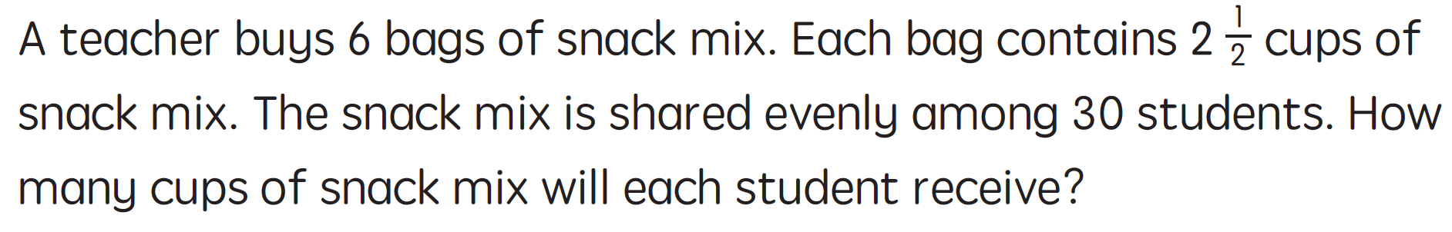

C.
