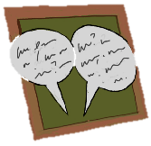
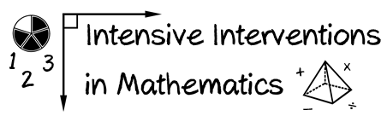
- Module 5
- Part 2
- Discussion
Create a poster for intervention use that students could refer to when solving word problems. Share it with colleagues.
Create an original post on the Discussion Board and respond to two peers.
(This space is for organizing your ideas.)

