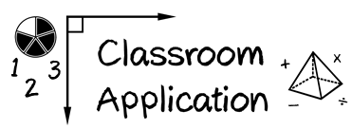

Module 5

(1) Identify three different word problems from your grade level’s assessment.

(2) What attack strategy would you use to help students solve these problems?

(3) Which schemas need to be the focus of instruction?

