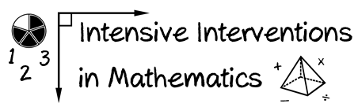
- Module 5
- Part 1
- Activity #3

Design your own Cover, Copy, Compare or Taped Problems to use within intensive intervention.

