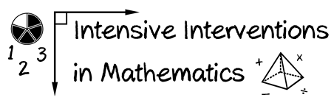

Module 4

Fill in the explicit instruction graphic organizer for an upcoming lesson.
Modeling |  | Practice
I Do |  |  | We Do
 |  |  | You Do
Supporting Practices

