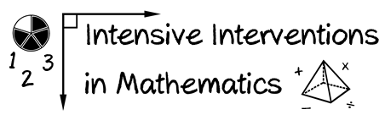
- Module 4
- Part 2
- Activity #5
Identify 10 concrete materials that you might want to use within intensive intervention.
Concrete Materials for Intensive Intervention
1
2
3
4
5
6
7
8
9
10

